國立臺中科技大學
National Taichung University of Science and Technology
學位論文原創性比對檢核表(口試申請)
Originality Comparison Checklist for Dissertations
(Oral Examination Application)
- 本人已經自我檢核，確認無違反學術倫理情事，論文倘有造假、變造、抄襲、由他人代寫，或涉其他一切有違著作權及學術倫理之情事，及衍生相關民、刑事責任，概由本人負責，概無異議。
  - I hereby certify that I have conducted a self-check and confirmed that there are no violations of academic ethics. I assume full legal responsibility for any instances of falsification, alteration, plagiarism, ghostwriting, or any other acts that infringe upon copyrights or violate academic ethics. I shall be solely liable for any resulting civil or criminal legal consequences and shall raise no objections.
- 本人之學位論文已確實經本校論文內容相似度比對系統檢核，內容比對相似度為
%（如有需要得另補充說明），符合系、所、學位學程自訂標準。
- Your thesis has indeed passed the content similarity comparison system of this university, and the content similarity is ________% (if any additional explanation is required), which meets the standards set by the department, institute, and degree program.

系所別 department：
學號Student number：
姓名(親自簽章) Name： (Signature)
論文題目Thesis Title：
論文口試日期： 年(Year) 月(Month) 日(Day)
Thesis oral exam date
申請日期： 年(Year) 月(Month) 日(Day)
Application date

指導教授簽章Professor's signature：
共同指導教授簽章（無免）：
Signature of co-supervising professor (no exemption)
系所（學位學程）主管簽章：
Department (Degree Program) Head's Seal
備註Remark：
- 研究生應於學位考試前完成論文原創性比對作業，填妥本檢核表後，連同原創性比對報告書全文送交指導教授簽章。
- Graduate students should complete the thesis originality comparison assignment before the degree examination, fill out this verification form, and submit it along with the full text of the originality comparison report to their supervisor for signature.
- 研究生於學位考試當日，應將論文原創性比對檢核表及原創性比對報告書送交學位考試委員參考。
- On the day of the degree examination, graduate students should submit the thesis originality comparison check form and the originality comparison report to the degree examination committee for reference.
- Turnitin論文比對系統相似度百分比指數，單純提供系所及指導教授依其學術專業參考之用，並非代表該學位論文有無違法學術倫理情事。
- The Turnitin thesis similarity percentage index is provided solely for departments and professors to use as a reference based on their academic expertise, and does not indicate whether the thesis violates any academic ethics.
- 比對時 排除引文與參考文獻後，總相似度需低於 30% (含)以下為原則，並符合系、所、學位學程自 訂標準比對之報告。
- When comparing, after excluding citations and references, the overall similarity should be below 30% (inclusive) and the comparison report should meet the self-defined standards of the department, institute, and degree program.
「原創性比對報告書全文」之步驟
Steps for obtaining the full text of the "Originality Comparison Report"
- 登入本校圖書館Turnitin系統，找到並開啟申請檢核的檔案。
Log in to the Turnitin system of the university library, find and open the file for review
系統指引System Guide https://library.nutc.edu.tw/database/search/DatabasesList.asp
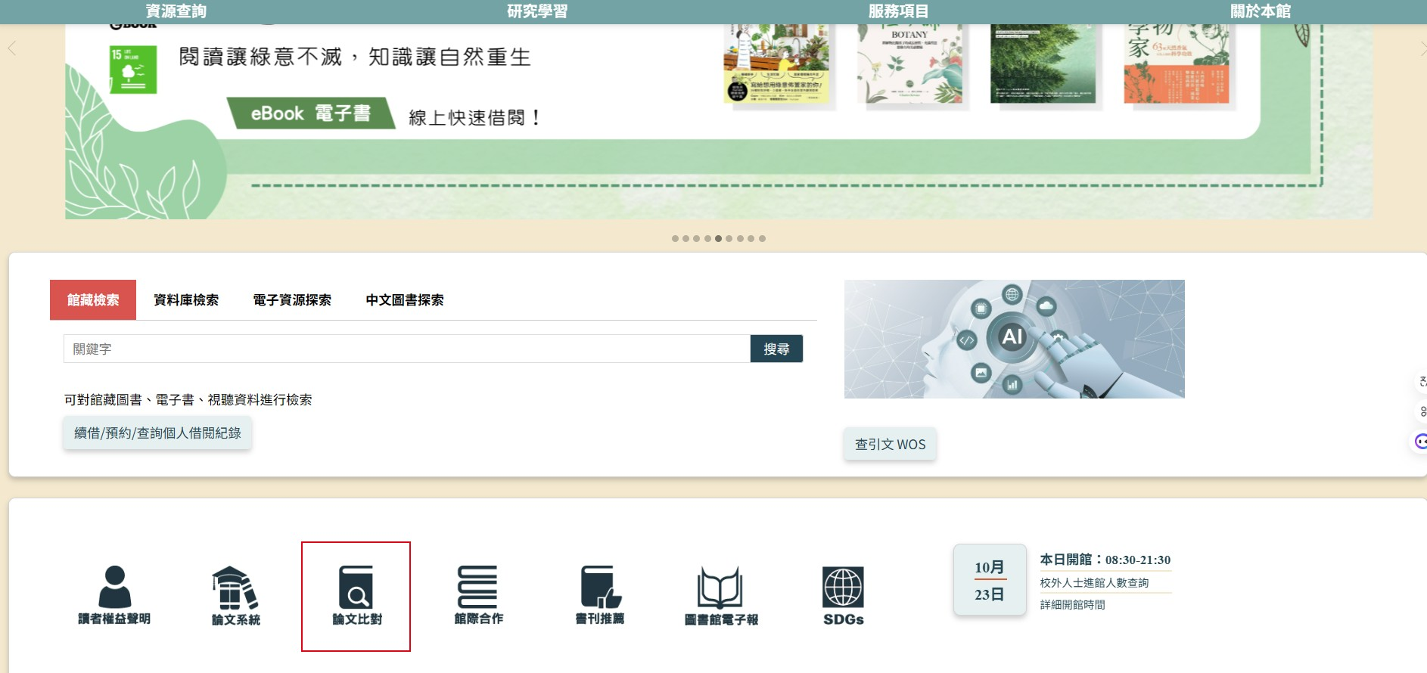
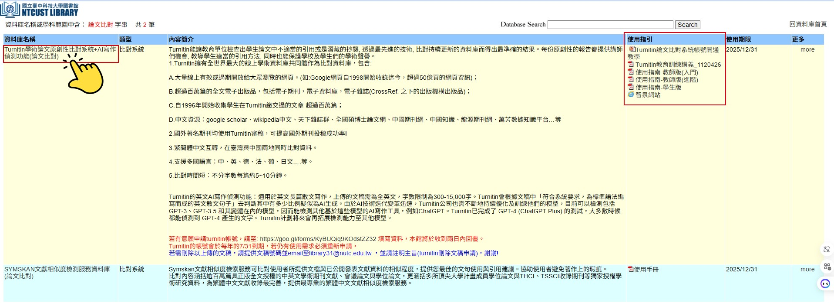
二、點擊下載符號後，選擇「目前檢視」，即會下載比對報告書全文PDF。
After clicking the download icon, select "Currently View" to download the full PDF of the comparison report.

